**PROJECT- 01**

**Serverless Image Processing**

# Create a serverless image processing application that automatically resizes and optimizes images uploaded to an Amazon S3 bucket.

SOURCE BUCKET AND DESTINATION BUCKET

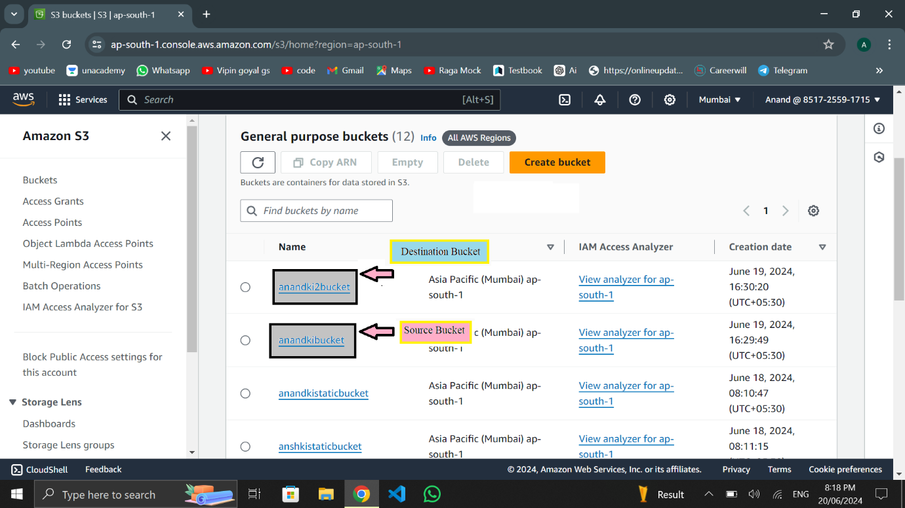

SIZE OF ORIGINAL IMAGES

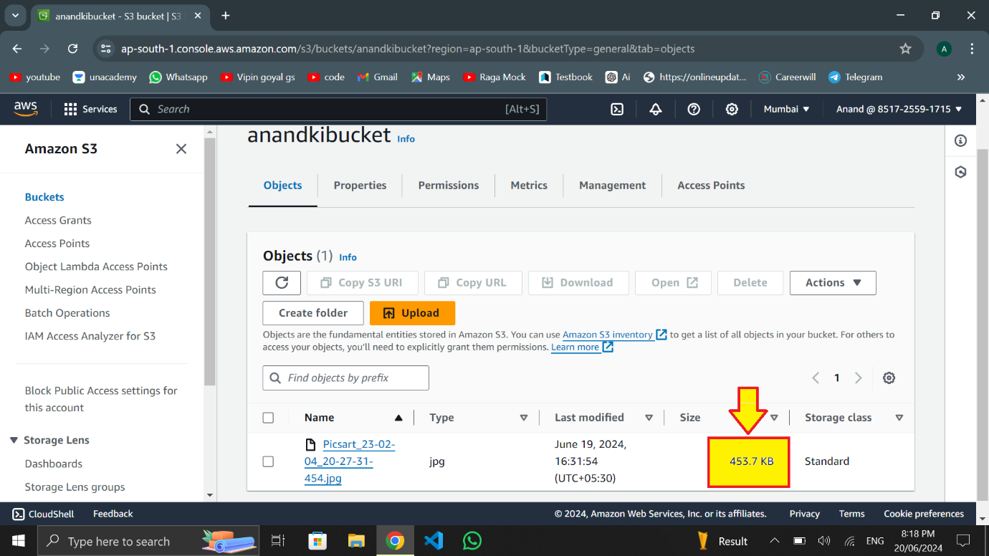

SIZE OF RESIZED IMAGES

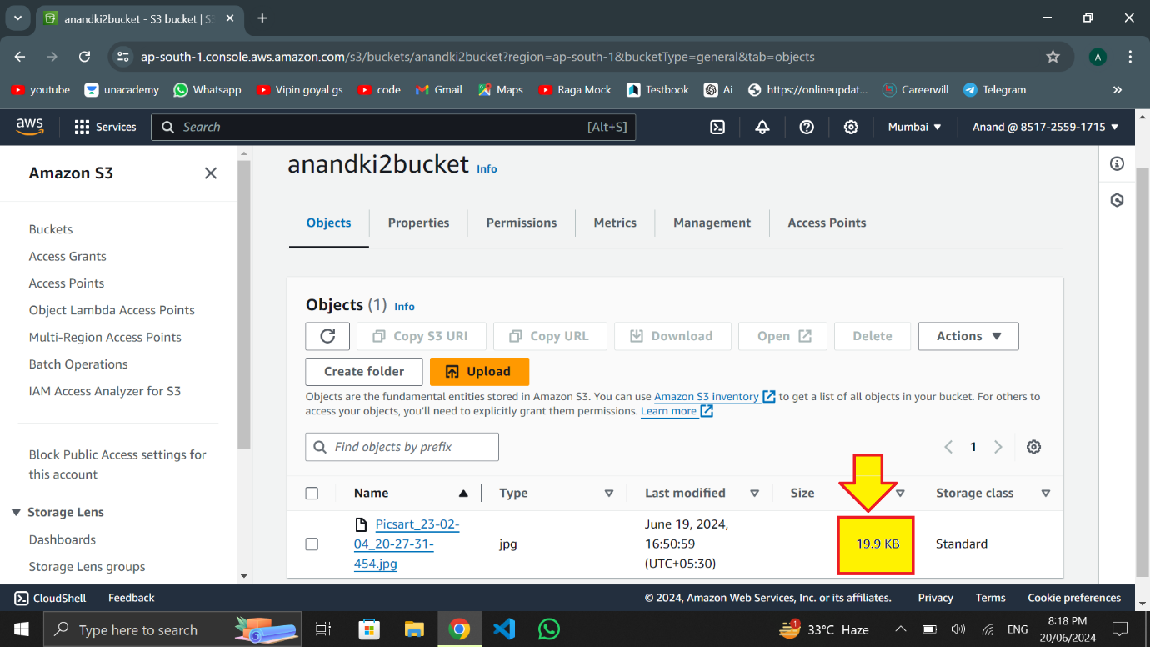

ORIGINAL IMAGES

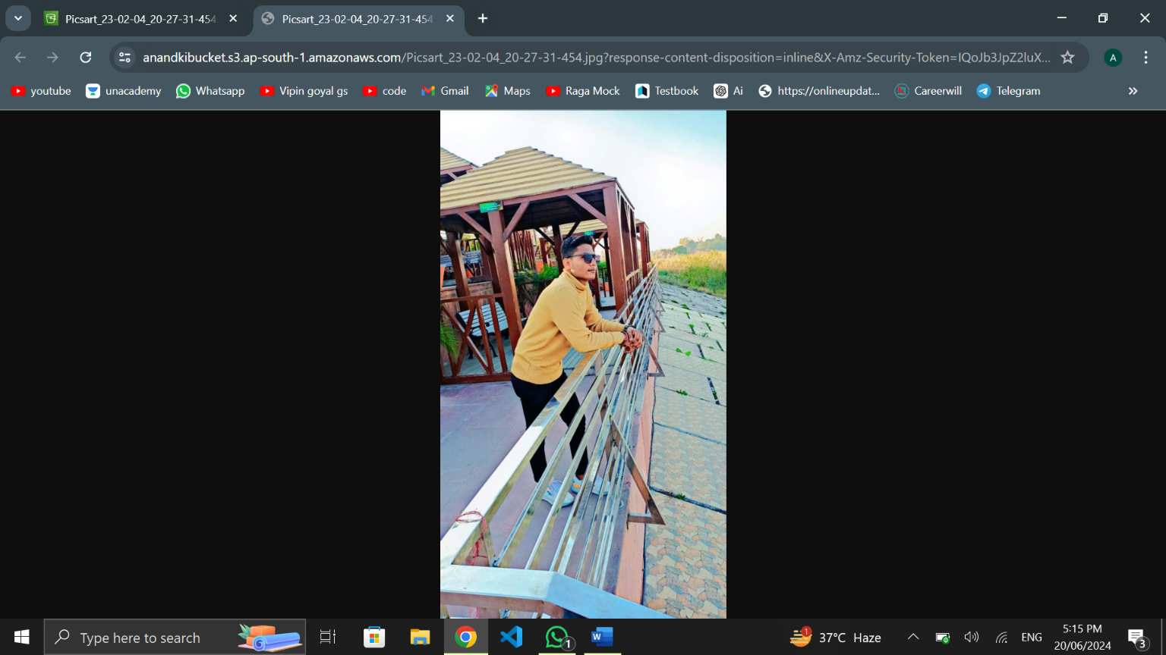

RESIZED IMAGES

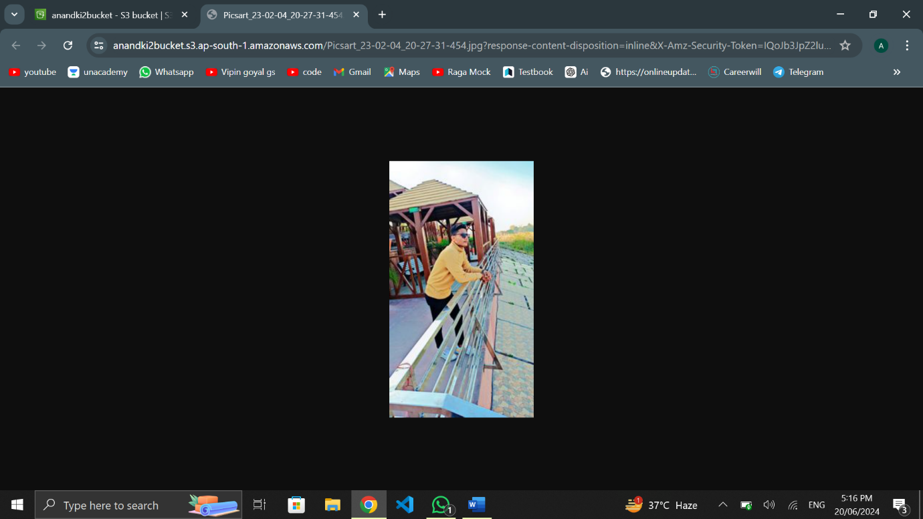

BY – ANAND MISHRA